Feature selection

Pearson correlation: It is a statistical measure of the strength of a linear relationship between two variables. The correlation coefficient ranges from -1 to 1, where -1 indicates a perfect negative correlation, 0 indicates no correlation, and 1 indicates a perfect positive correlation.
We take dataset on “Student’s Mental Health”. Now, let's use these statistical tests on the "student_mental_health.csv" dataset. This dataset contains data about the mental health of students, including various attributes such as age, gender, academic performance, etc.
Let's use the Pearson correlation to find the correlation between two continuous variables for all the Attributes to Attributes and Attributes to Class.
Correlation between Attribute to Attribute: All our independent attributes are Gender, Age, Marital status, Anxiety, Panic attack & Depression.
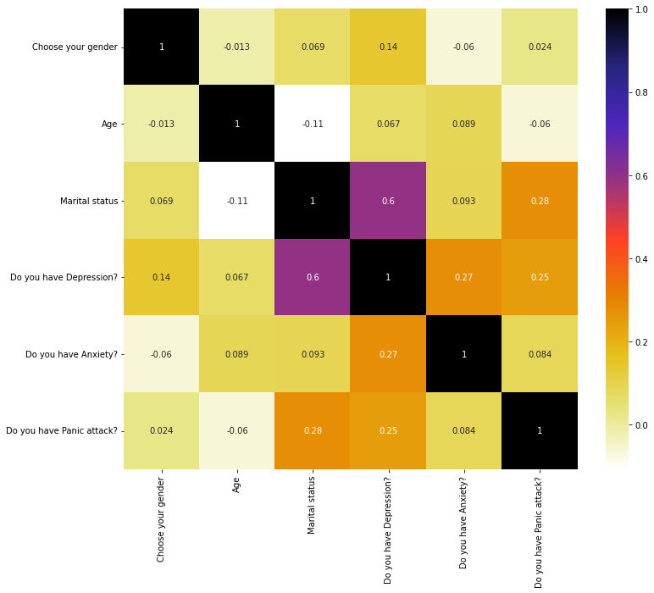
From the above plot of Pearson Correlation we can see that there consists both positive and negative correlation. The Pearson correlation coefficient between ‘Gender’ and ‘Age’ is -0.013, this means that when one variable increases as the other decreases, and vice versa. Most of the correlation lies between 0.06 – 0.09, which indicating a weak positive correlation between these attributes like ‘Anxiety’ & ‘Marital status’, ‘Age’ & ‘Depression’, ‘Anxiety’ & ‘Age’ etc. This means that as one attribute increases, there is a slight increase in other attributes level. We find that the most highly Correlation exists between the attribute “Depression” & “Marital Status” which is 0.6 means 60%.
Correlation between Attribute to Class: In our dataset our class is “Seeking specialist treatment”. We conclude a decision regarding this by analysing all our independent attribute.

 | Seeking Specialist Treatment
Gender | 0.052
Age | -0.049
Marital Status | 0.35
Depression | 0.35
Anxiety | 0.087
Panic attack | 0.18

From the above chart we can see that Class is highly correlated with two attributes “Marital status” & “Depression”. It’s also have weak correlation with other attributes.
Selection of Correlated Features: For finding the correlated features, pearson correlation use Threshold values. Depending on this threshold the correlated features will selected. This threshold values is selected by us. Most of the time it will say that this Threshold value is at least 70% correlated, then we will remove the feature. But in our dataset as most of our attribute is object type & thus we converted this object data to numeric data for finding the pearson correlation. For this, most of our coefficient value lies 0.2 – 0.09 that means we can’t even get 60-90% coefficient value for this data conversion. For this reason we select our Threshold value 0.2 as we get highest correlated features in this value.

Our Correlated features are –

Corr_features | Anxiety
Corr_features | Depression
Corr_features | Panic Attack

Chi-square test: It is a statistical test used to determine whether there is a significant association between two categorical variables. The test determines if the observed frequency of a category is significantly different from the expected frequency.
Let's use the Chi-square test to find the correlation between two continuous variables for all the Attributes to Attributes and Attributes to Class.
F-value & P-value for feature selection: In the context of the chi-square test, the F-value and the p-value are two important statistical measures used to determine whether the null hypothesis should be rejected or not.
The F-value, also known as the test statistic, measures the degree of association between the two categorical variables.
The p-value is a probability value that is used to determine whether the observed association between the two variables is statistically significant or just due to chance. A p-value less than the significance level (usually 0.05) indicates that the observed association is statistically significant, and we reject the null hypothesis. On the other hand, a p-value greater than the significance level suggests that the observed association is not statistically significant, and we fail to reject the null hypothesis.
In our dataset our obtaining F-value and p-values are –
Attribute | F-value | P-value
Gender | 0.20411606 | 0.651419
Age | 0.07318634 | 0.786753
Marital Status | 1.9579773 | 0.161730
Depression | 4.16842105 | 0.041184
Anxiety | 0.25663786 | 0.612439
Panic attack | 1.09484004 | 0.295401

The F-score needs to be higher. The more the F-score is the more important the feature is. & the P-value needs to be lower. The more lower the P-value is the more important that feature is. From the above table we can see that the attribute “Depression” has the larger F-value & the lowest p-value. Thus this feature is mostly important.
Selection of Correlated Features: From the chi square test we got below highly correlated features –
Corr_features | P_Values
Age | 0.786753
Gender | 0.651419
Anxiety | 0.612439
Depression | 0.041184
Panic Attack | 0.295401
Marital Status | 0.161730
In Chi square test we got the features that we also got in pearson correlation. But in this test we got some extra features also that we didn’t get in pearson. This is because in pearson we select the Threshold value by ourselves and we also select low value as we got maximum feature in that case. We choose the low value because of our data conversion. But in Chi square test we need not have to take any value by ourselves. Thus we got some extra features along with old features.

